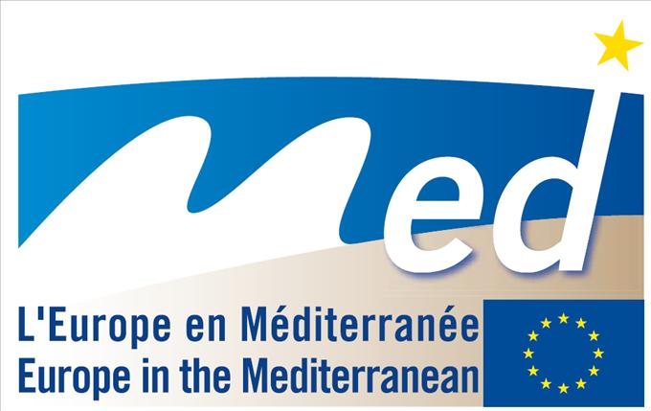 |  | 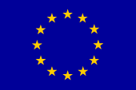
EUROPEAN TERRITORIAL COOPERATION  TRANSNATIONAL COOPERATION PROGRAMME MED |  | EUROPEAN UNION  EUROPEAN COMMISSION

Seminar, 22 and 23 September 2009
“CLUSTERS IN GREECE: CURRENT SITUATION AND DEVELOPMENT PROSPECTS”
Crowne Plaza Athens City Centre Hotel, 60, Michalakopoulou Ave., 11528
Athens - Greece

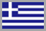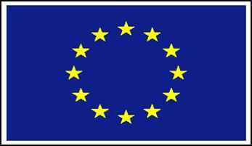
«The project is co-funded by the European Regional Development Fund and by national funding»



HELLENIC REPUBLIC - MINISTRY OF DEVELOPMENT

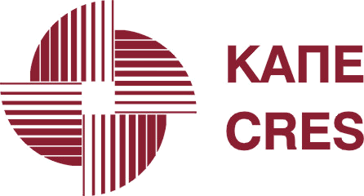

CENTER FOR RENEWABLE ENERGY SOURCES AND SAVING



MED PROJECT “IC-MED”: Inter-Clusters Mediterranée

PROVISIONAL PROGRAMME

Tuesday, 22 September 2009
Morning

09:00 – 09:30 Registration
09:30 – 09:40 Welcome Greeting
D.Papastefanakis, Director of Development Programs Division, CRES, Greece
J.-C. Tourret, General Delegate, Institut de la Méditerranée, France

09:40 – 10:15 Session I: The IC-MED project: opportunities for new projects / cooperations

IC-MED - Inter -Clusters Mediterranée: a short introduction to the project

E.Karakatsani, Department of Development Project Studies, CRES, Greece

Transnational cluster cooperation and project approach

J.-C. Tourret, General Delegate, Institut de la Méditerranée, France

10:15 – 11:15 Open Discussion: Transnational cooperation through cluster initiatives (Q&A)
11:15 – 11:30 Coffee Break
11:30 – 11:45 Session II: The vision of a Sustainable Building Cluster in Greece

Possibilities of cooperation for Sustainable Building Clusters

J.C. Tourret, Institut de la Mediterranee, France

11:45– 12:30 Open Discussion: Cooperation between sustainable building clusters (Q&A)
12:30 – 14:00 Lunch Break
** All participants will be able to take part in special work meetings which will be organized at CRES on the 23 September, providing them with the opportunity to exchange experiences and put forth the basis for new, fruitful collaborations

Tuesday, 22 September 2009
Afternoon

14:00 – 15:30 Session III: Good practices and Opportunities in the field of Cluster development in Greece

Introduction on Transnational cluster cooperation and project approach

J.C. Tourret, Institut de la Méditerranée, France

CORALLIA Clusters Initiative

A. Konstantopoulou*, PR & Communications Associate, Greece

Hellenic BIO-CLUSTER

R. Kardara*, Technology Transfer Consultant, Greece

Energy efficient sustainable buildings in Greece
E. Tzanakaki, Buildings Department, Division for Energy Efficiency, CRES, Greece

15:30 – 16:30 Open Discussion: Potential benefits from a cluster for sustainable building in Greece (Q&A)

Wednesday, 23 September 2009

9:00 – 13:00 : Bilateral interviews (20-30 min per interview)

Blue Water Economy Cluster, N. Samaras, President of the Institute of Port Development

Energy-related cluster, Regional Innovation Strategy of Western Macedonia (RIS W,M.)*
Y. Fallas, Coordinator of RIS W.M.

Water-Tech Cluster, Regional Innovation Pole of Western Greece
V.G. Papadakis, Associate Professor, Department of Environmental and Natural Resources Management, University of Ioannina
i4 Crete, Regional Innovation Pole of Crete*
Aggelakis Antonis, Liaison Officer

Clusters in the Region of Peloponnesus* –formed during the NetForce2006 Project A. Andricopoulou, Project Manager

*To be confirmed

