Kythnos 2008 Symposium on Microgrids

The Public Power Corporation (PPC) of Greece, the National Technical University of Athens (NTUA), and the Centre for Renewable Energy Sources (CRES) are pleased to organize and host the 4th in the series of Microgrid Symposiums, on Kythnos Island, on 2 June 2008.
In the framework of the 4 th Microgrid Symposium will also be organized the Technical Tour: Visit to the first European wind park (1983) and the Gaidouromantra Microgrid Site.
Schedule of Events
Date | Time | Event
Sunday 1st June 2008 | 10:00 – 13:00 | Technical Tour: Visit to the first European wind park (1983) and the Gaidouromantra Microgrid site*
Monday 2nd June 2008 | 9:00 – 17:00 | Microgrid Symposium**

* Technical Tour will be open.
** Participation in the Symposium is by invitation only

Transportation during the Technical Tour
As Kythnos is a small island and the means of transportation are limited, organizers will arrange the transportation for the Tour, but priority will be given to the participants of the Symposium. Those who are not participants of the Symposium should also make arrangements for their transportation to and from the visiting sites.
THE CYCLADES ARCHIPELIGO
The Cyclades are a group of islands of varying sizes scattered over the deep blue waters of the Aegean Sea to the east of the Peloponnese Peninsula and south-east of the coast of Attica.
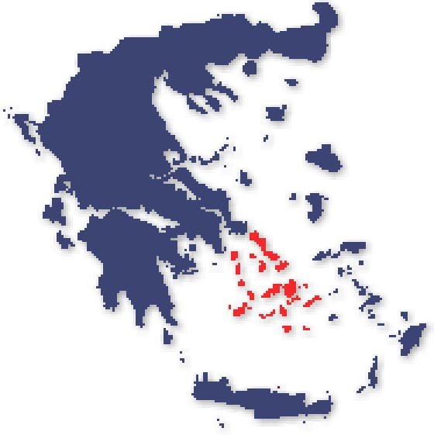

Greece
The Cyclades Group
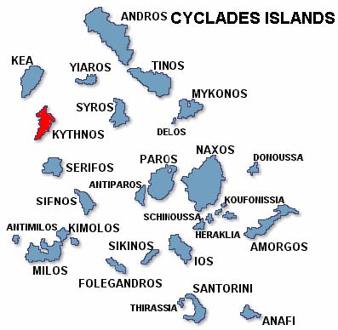
KYTHNOS ISLAND
The island of Kythnos is located between Kea (Tzia) and Serifos, 100 km from Pireaus. Administratively, Kythnos belongs to the Kea province of the Cyclades Prefecture. Its area is about 100 km² and its circumference 58 km. The permanent population is about 1600 people, but during the summer tourist season the population may double. Residents are mainly employed in livestock and other agriculture, fishing, or tourism. The climate is dry with relatively cool summers favouring cultivation, but soils are poor. The island has good wind and solar potential. More information about the island can be found at http://www.kythnos-island.com/eng/.

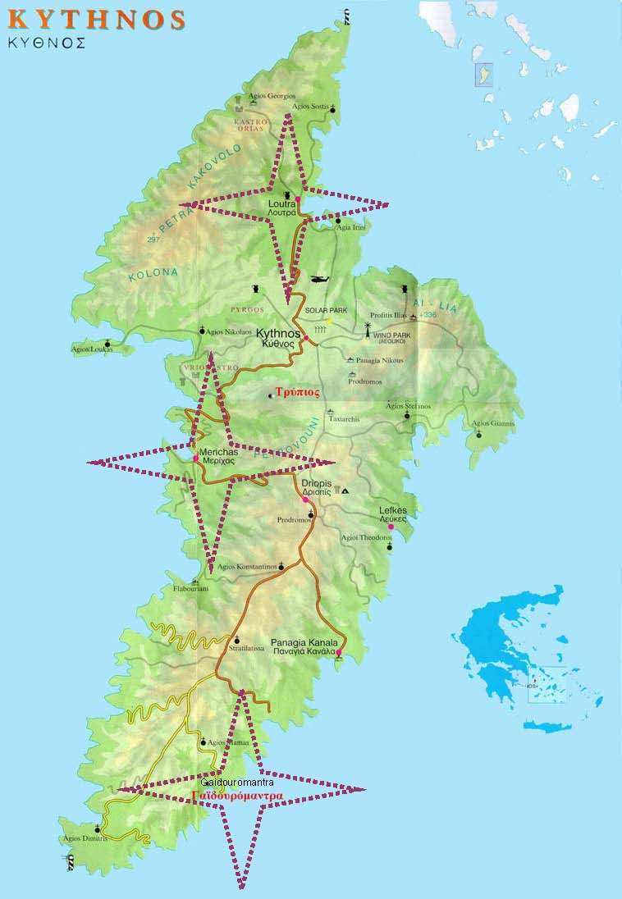

TECHNICAL TOUR OF THE GAIDOUROMANTRA MICROGRID
The technical tour of the Gaidouromantra microgrid demonstration site near the southern tip of the island is planned for Sunday 1st June. Bus transportation will be provided.
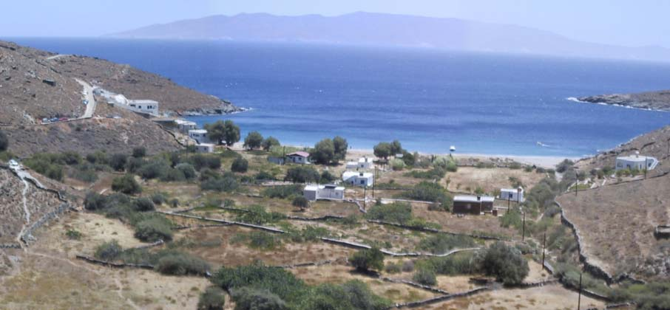

View of Gaidouromantra
This settlement is about 4 km from the closest medium voltage line. The grid and safety specifications for connections meet the technical standards of PPC, which is the local electricity utility, because eventually the microgrid may be linked to the island grid. The microgrid is 3-phase and composed of overhead power lines with parallel communications, serving 12 houses in a small valley. The peak power in each house is limited by a 6 A fuse. A 25 m² equipment shed was built in the middle of the settlement to house the battery banks and inverters, a diesel genset and its fuel tank, computer equipment for monitoring, and the communications hardware. The grid electrifying the homes is powered by 3 Sunny-island battery inverters synchronized to three-phase at 400V and 50Hz. Each battery inverter has a maximum power output of 5 kW. The battery inverters have the capability to operate in both isochronous or droop mode. Operating in frequency droop mode enables passage of information to switching load controllers when the battery charge is low and limits the output of the PV inverters when the battery bank is full. In the wider EU project More-Microgrids, local controllers were developed that fit into the house AC plugs facilitating control of individual loads using agents. Work is in progress to install a Microgrid Central Controller at the System House responsible for optimization of operations, or alternatively, to simply coordinate local controllers, which then assume primary responsibility for optimization. In the centralized approach, all necessary decisions are made by a central controller, while in the dispersed approach, agents negotiate though the communication link to arrive at solutions. Addition of a 5 kW 3-phase wind turbine is planned.
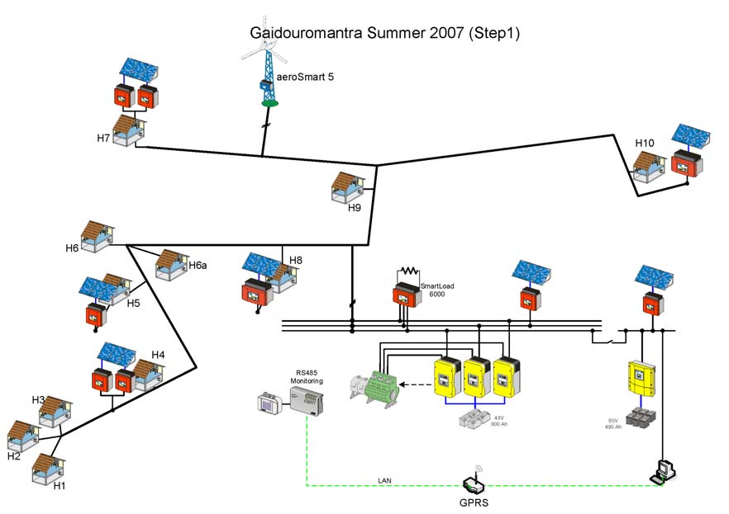

Phase 1 of Gaidouromantra Microgrid Modification
The current microgrid is composed of 10 kWp in multiple small PV arrays, a battery bank of a nominal 53 kWh capacity, and a diesel genset with a nameplate rating of 9 kVA. The PV modules are integrated as awnings into various houses. A second system provides power to the monitoring and communication equipment, and consists of about 2 kWp of PV mounted on the roof of the System House connected to a Sunny-island inverter and a nominal 32kWh battery bank. The installation of the grid and the systems was performed within two European Commission projects (PV-MODE, JOR3-CT98-0244 and MORE, JOR3CT98-0215). The current system upgrade is part of the European Commission’s More-Microgrids (http://microgrids.power.ece.ntua.gr/micro/index.php).

