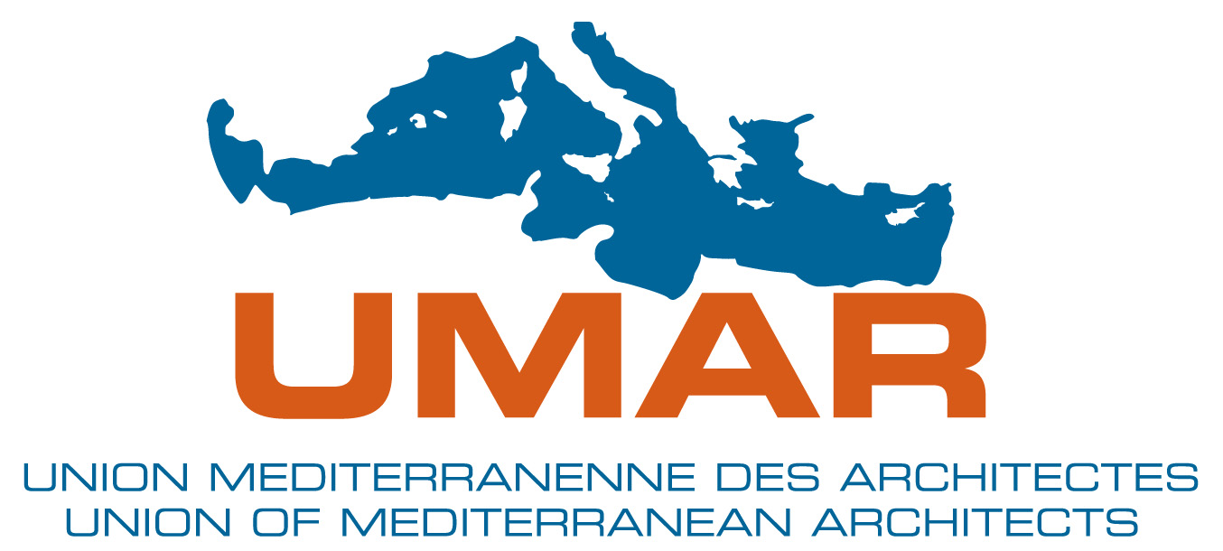 | 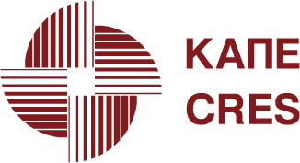 | 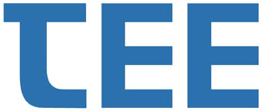

SOLARBUILD

"INTEGRATION OF SOLAR TECHNOLOGIES INTO BUILDINGS IN MEDITERRANEAN COMMUNITIES"

WORKSHOP, 12-13 December 2007
National Research Foundation, Athens, Greece

PROGRAMME

Wednesday, 12 December 2007

17:30 – 18:00 Registration

18:00 – 19:30 Opening Session: Solar Technologies Prospects in Mediterranean
Chairman: Vassilis GrIgoriadis, Architect

- Minister of Development, Christos FOLIAS
- President of UMAR, Patrice GENET
- President of CRES, Giannis AGAPITIDIS
- President of the Technical Chamber of Greece, Giannis ALAVANOS
- European Commission Representative
- President of the Association of Greek Architects, Takis Georgakopoulos

- “SOLAR BUILD PROJECT”, Dimitris. PAPASTEFANAKIS, Director of Development Programs, CRES

19:30 – 20:30 Cocktail

Thursday, 13 December 2007

9:00 – 9:30 Registration

9:30 – 11:15 Session I: The Experience from Central and Eastern Mediterranean
Chairman: Dimitris Maraveas, Architect

- JORDAN, Ammar Al TAHER, NERC
- SPAIN, Manuel SAINZ, IDEA
- ITALY, Gaetano FASSANO, ENEA
- LEBANON, Tony MATAR, ALMEE
- PALESTINIAN AUTHORITY, Hussein HAMED, PEC
- GREECE, Evi TZANAKAKI, CRES

- “Brief Presentation of the Experience in Western Mediterranean: Algeria, France, Portugal, Morocco, Tunisia”, Markos DAMASSIOTIS, CRES

11:15 – 11:45 Coffee Break

11:45 - 13.30 Session ΙI: Perspectives of the Build Environment
Chairman: Christos Sinanis, Mech/El. Engineer

- “Environmental quality of the build environment in Mediterranean communities”, Prof. Manthos Santamouris, University of Athens
- “SD-MED methodology for the application of sustainable development to the build environment “, Dr. Stella Kivellou, President of SD-MED Network
- “Market perspectives for solar thermal systems in the Mediterranean”, Manolis Kastanakis, President of SEIA
- “The concept of a densely populated, positive energy, settlement adapted to the Mediterranean climate”, Zygmunt KNYSZEWSKI, Responsible for the UMAR summer school in PERPIGNAΝ, France
- “Solar cooling and energy efficiency in the Agricultural University of Ankara, Turkey”, Eleftheria Alexandri, CRES

13:30 – 15:00 Lunch break

15:00 – 16:30 Round Table: Opportunities for Future Cooperation

- Representative of the Ministry of Development
- Representative of the Ministry of the Environment, Physical Planning & Public Works
- David PACE, General Secretary, UMAR
- Dimitris PAPASTEFANAKIS, Director of Development Programs, CRES
- Nikos FINTIKAKIS, Director of the Program ARES of UIA, Technical Chamber of Greece
- Nikos AgrIantonis, President, Hellenic Branch of ICOMOS

Discussion

