Energetic Module

The Energetic Module is a simulation tool based on TRNSYS, with a user friendly interface where the user can introduce all technical data referred to the solar thermal system through seven different screens:

- Main
- Loads
- Solar field
- Production
- Control
- Simulation parameters
- Project data

Here are shown:

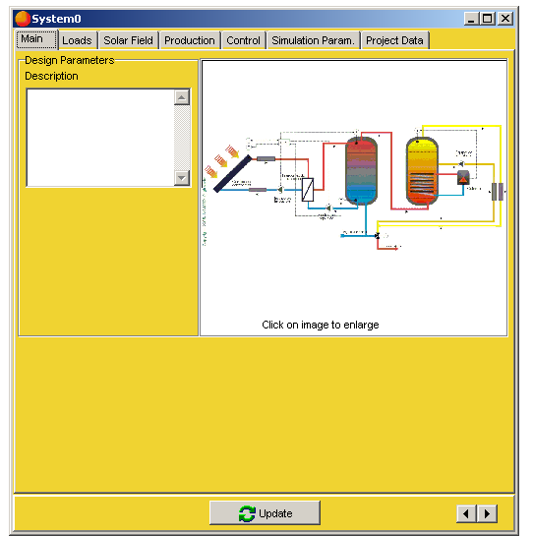 | 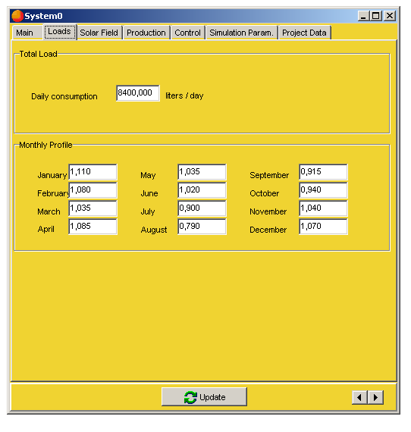
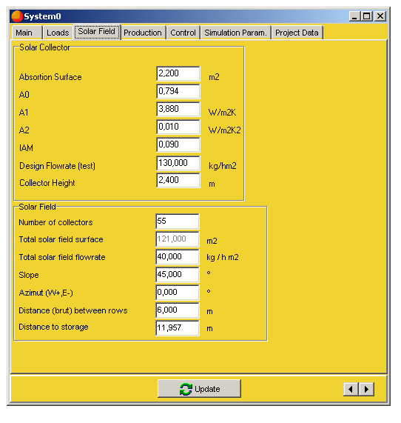 | 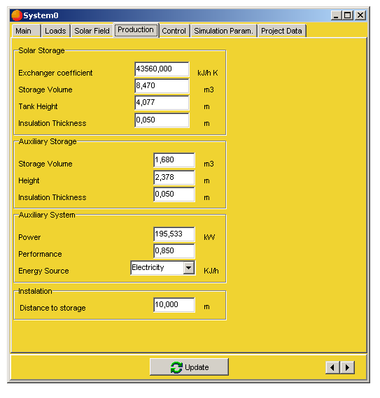
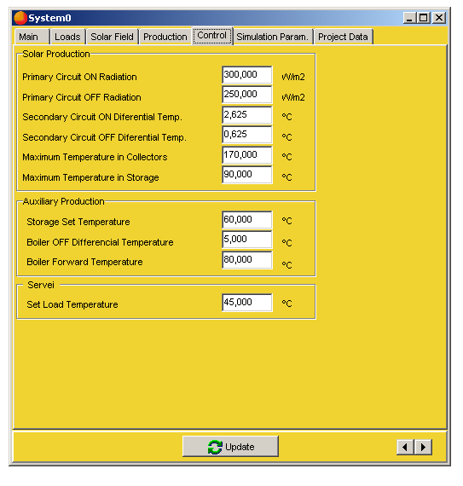 | 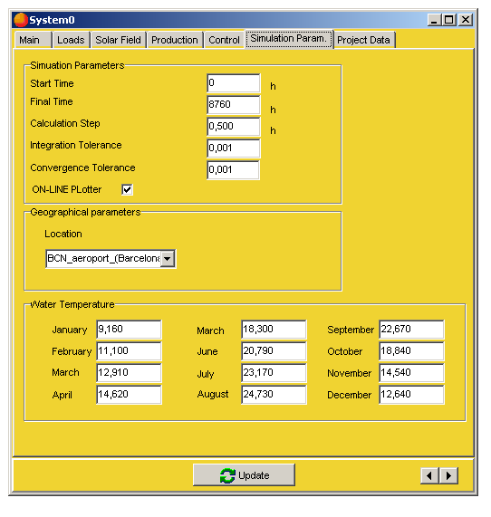
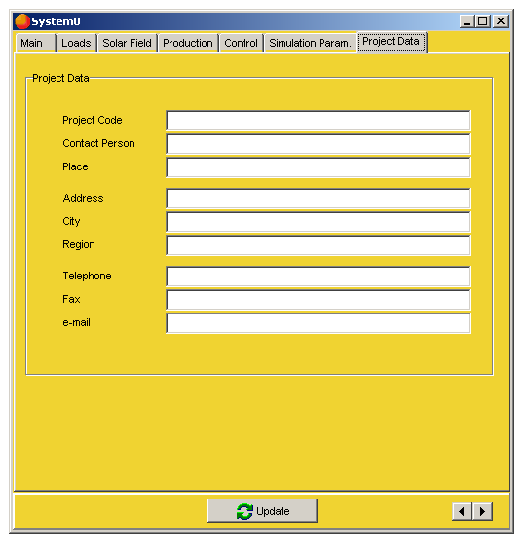
The transient simulation tool allows the user to reach a very good estimation of the solar field production. The possible difficulties of a non expert user in the definition of the value for the parameters is solved by a correlations system that suggests to the user all the values included in the software depending of some initial definition values.

The tool includes a help file in html .

Finally, this tool generates a simulation report with all energetic data. Its as it follows:

Economic Module

The Economic Module is the one that does the economic, financial and contractual analysis, based on the EnMo results or other energetic results coming from any other energetic software.

An instruction screen allows the user to import EnMo results and to introduce other description parameters.

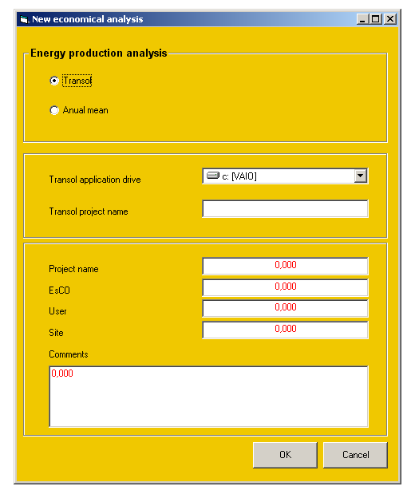

After this, depending on the values imported, a base project is generated and shown. From here the user is able to change whatever.

The data input is organized in two different screens, and a final interactive screen for the final optimization of it all:

- Input data
  - Basis System Description
  - Conventional System Description
  - Economic Data
  - System Ongoing Cost
  - Solar System Savings

- Contract definition

- Interactive Financial Calculations

All this screens are shown below:

